Tool Guide – ARP Fingerprint

Introduction
ARP Fingerprint is a network reconnaissance tool used to identify and profile devices on a local network by analysing their ARP (Address Resolution Protocol) responses.
By comparing response patterns with known fingerprints, the tool estimates the possible operating systems or device types present on the network.
Within the Deakin Detonator Toolkit, ARP Fingerprint is used during local network reconnaissance to gain visibility into connected devices prior to deeper scanning or enumeration.
Ethical Use Notice
ARP fingerprinting must only be conducted on networks that you own or have explicit permission to test.
Monitoring or profiling unauthorised networks is unethical and may be illegal.

Setup and Launch
  - Step1: Open Deakin Detonator Toolkit
- Open a terminal in Kali Linux.
- Navigate to the toolkit directory:
cd Deakin-Detonator-Toolkit
- Start the application:
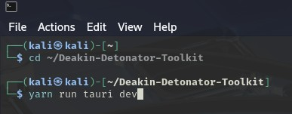
yarn run tauri dev

  - Step2: Find Tool-example
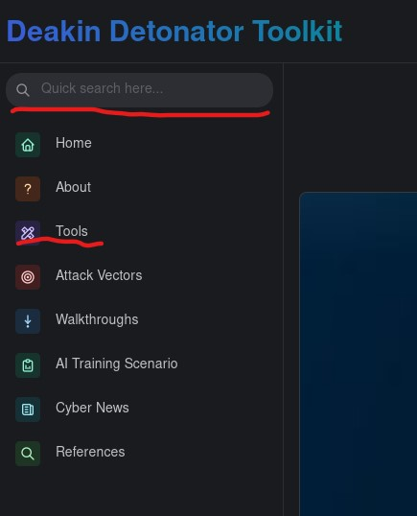
- Click Tools in the left-hand navigation menu.
- Locate ARP Fingerprint in the list.
- Click the Go button to launch the tool.

Configuration and Usage
  - Step3: Configuring ARP scan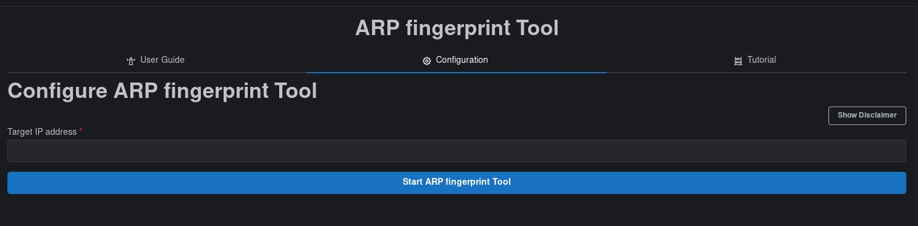
- Enter a Target IP Address.
  - You may test your own system or a device on a permitted network.
  - To identify your local IP address, run:
  - ifconfig
- Click Start ARP Fingerprint Tool.
- When prompted, enter your system password to allow authenticated execution.
  - Step4: Results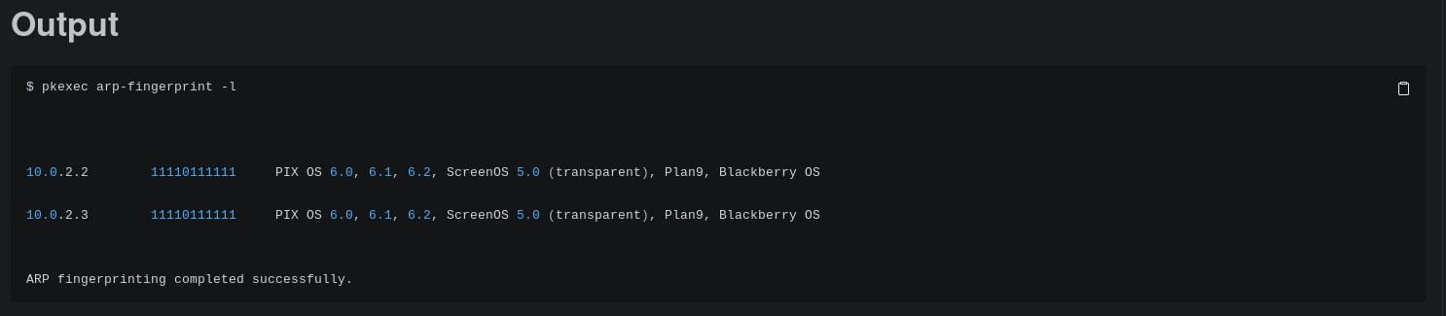
- The output panel will display detected hosts and their ARP fingerprint patterns.
- The scan completes with a confirmation message indicating successful execution.
- Optional actions:
    - Save the output to a file
    - Copy results to the clipboard
    - Clear output to perform additional scans

Output Explanation
Note: your output will naturally be dependent on what network interface you checked and your devices, the following is non-comprehensive example output of an example IP address.
- $ pkexec arp-fingerprint -l
  - This is the command used by the ARP fingerprint tool to check an IP address, though with the -l, it scans the local network for all available devices, it can appear as “pkexec arp-fingerprint (IP address here)” instead.
- 10.0.2.2 11110111111 PIX OS 6.0, 6.1, 6.2, ScreenOS 5.0 (transparent), Plan9, Blackberry OS
  - 10.0.2.2: a detected IP address
  - 11110111111: an ARP fingerprint bit pattern
  - PIX OS 6.0, 6.1, 6.2, ScreenOS 5.0 (transparent), Plan9, Blackberry OS: possible operating systems that match the ARP fingerprint
- The 10.0.2.3 one is basically identical to 10.0.2.2
- And finally, an ending message “ARP fingerprinting completed successfully”
Troubleshooting
- Repeated authentication prompts: Ensure correct system credentials are entered.
- No devices detected: Confirm network connectivity and correct IP range.
- Permission denied errors: Restart the toolkit and approve privileged execution when prompted.
Learning Outcome
After completing this guide, you should be able to:
- Perform ARP-based fingerprint scans
- Interpret ARP fingerprint results correctly
- Use identified devices as targets for further authorised testing

